SAP Application Development

(S/4 HANA)

Modularization

Content  This chapter is about subdividing program parts in several independent function modules. You will learn how to create and use function modules to reduce the complexity of your main program. | Prerequisites  You should be familiar with basic ABAP development and have experience in navigating with SAP GUI and Eclipse. Furthermore, you should have completed the chapter Introduction to SAP Programming.
Motivation  Nowadays, it’s hard to fulfill both application requirements and good conditions to enable easy source code maintenance. That’s why developers should try to reuse existing program parts as often as possible and follow the paradigm “divide-and-conquer” by making use of modularization. This chapter is an excellent introduction to start modularization by creating and using function modules. | Lecture notes  Fundamental knowledge about ABAP development is a prerequisite for the students. Students can go on with their account from the previous chapters.

- Product: All

- Level: Advanced

- Focus: Programming

- Version: 2.0

- Author: UCC Technical University of Munich

Task 1: Login into the SAP system within Eclipse
Short description: Use Eclipse to login into the SAP system with your username and password
Login

Start Eclipse and select the local workspace where your ABAP project is stored.

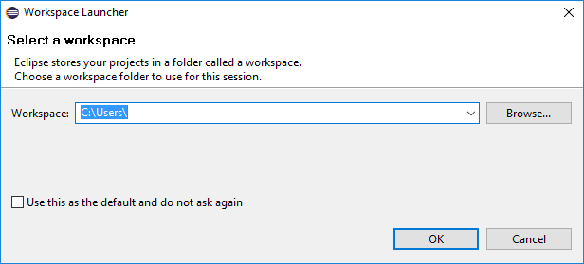

Please refer to the local workspace of Module “Basic Concepts” where you learned how to create first programs in ABAP. If you haven’t finished the exercise from Module “Basic Concepts”, please perform task 2 and 3 of the exercise before you continue with this one.

Task 2: Code outsourcing – making use of function modules
Short description: Use a function module to separate a certain method from the main program

You already learned how to use the main program to perform certain calculations. With this exercise you get to know how to organize your program more effectively by outsourcing as much as possible to function modules.

In this task we want to separate the calculation from the main program and want to use a function module instead. Therefore, create a new function group called ‘Z_$$_###_CAR_FUNCTIONGROUP’. This can be done easily by performing a right click onto your Source Library:

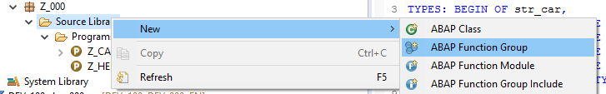

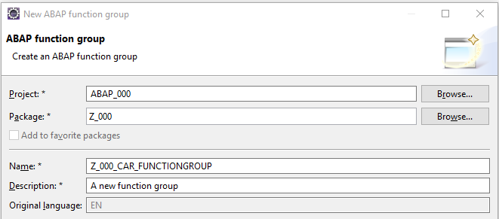

Please refer to a previous transport request or create an own one if you want to separate this work from the other ones you did before. Afterwards, perform a right-click onto your new Function Group and select

New • Function Module

Please create a new function module which is named Z_$$_###_CAR_FM_CALCULATION.

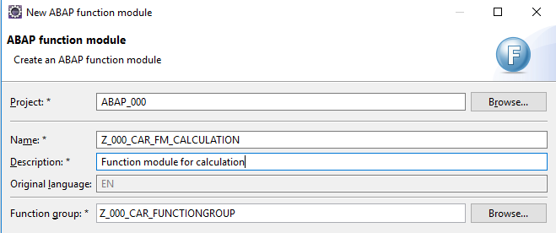

In the source code of your new Function Module perform a right-click and select:

Open With • SAP GUI

Import
Switch to the ‘Import’ tab and activate the edit-mode. In our scenario we want to import three parameters: IM_TRIP_F, IM_TRIP_M and IM_COUNTRY. Besides, you have to define the parameters data type and activate the checkbox for passing their values.

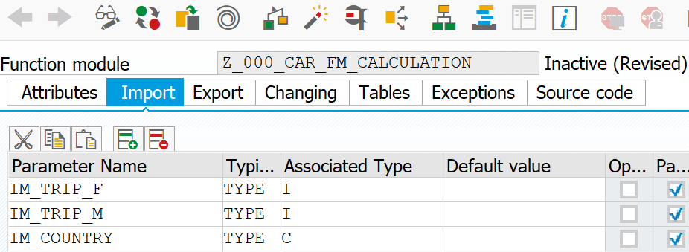

Export
Now switch to the ‘Export’ tab. Here you have to define all variables to be exported by the function module. Please define the variables EX_RESULT and EX_TEXT to be exported.

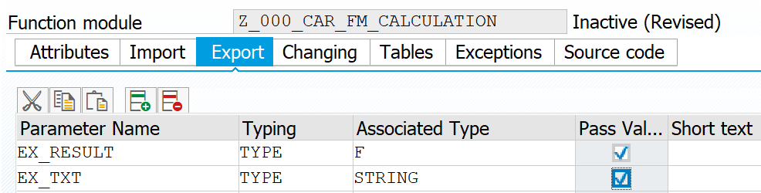

Save and activate your changes now. Afterwards, close the integrated SAP GUI. Refresh your source code in Eclipse. The interface definition has already been created by the system. If you change the interface definition here, it will not affect the importing and exporting parameters as this is just text without any further semantic behind. In the source code of your function module you implement the new ‘CASE’ instruction whereas you have to replace the old parameter names (e.g. trip_f) with the new ones (IM_TRIP_F). Your new source code should look similar to this:

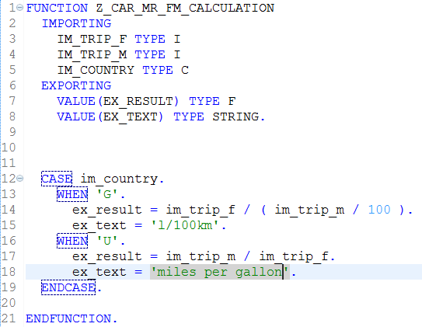

Do not forget to save, check and activate the function module/group. You may test the new function module directly.

Call Function
In this step we want to replace the case instruction in your program by a function call. Obviously the function to be called is your new created function Z_$$_###_CAR_FM_CALCULATION. Therefore, switch back to your program Z_$$_###_CAR. Add a function call by entering ‘CALL FUNCTION’ and use the auto completion feature by pressing Ctrl + Space, select your function module and press Shift + Enter in order to let the system automatically insert the new function call and a kind of skeleton. You only have to assign the variables to the importing and exporting parameters.

Hint:
Importing vs. Exporting
When you call a function within your program the exporting parameters always describe parameters, which are exported to the external function module. The importing parameters are parameters, which are imported to the current program.

Complete the source code similar to the following screenshot:

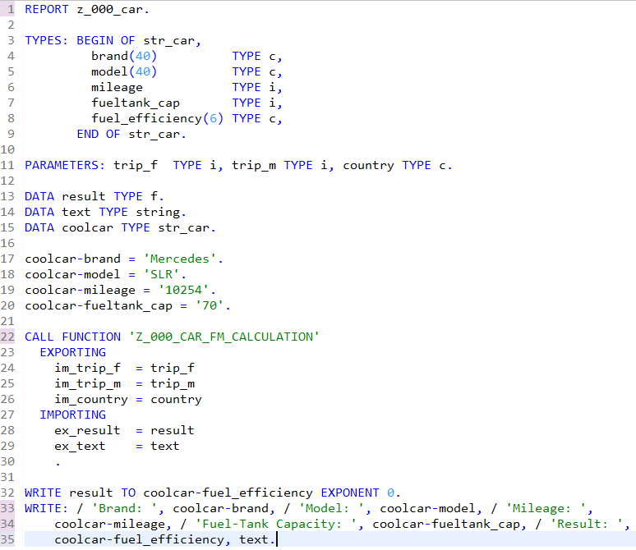

Activate everything!
Save, check and activate your program. Now you can test the program with your new function call.

Challenge:
Short description: Extend your program with a subroutine to convert miles in kilometers in order to provide the information of fuel efficiency also within European measurement units.

